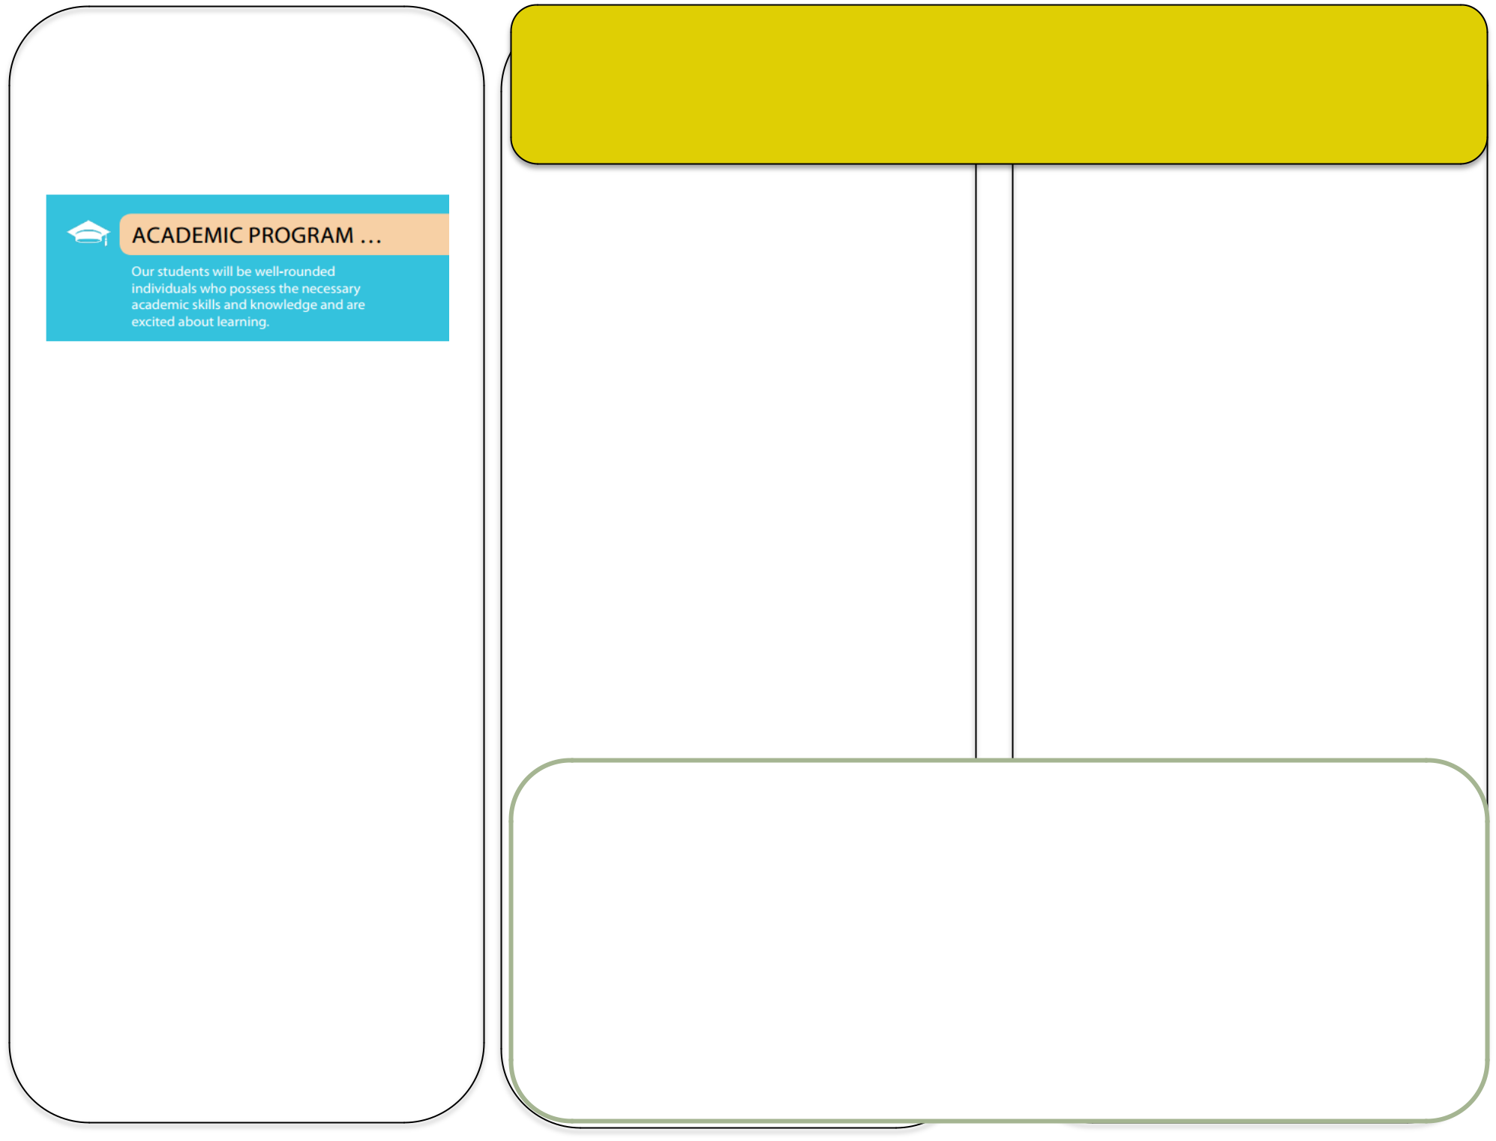

***Our Goals for Student***

***Achievement***

*Atlanta Public Schools’ Goal*

***Teachers, Parents, and Students – Together for Success***

**In the Classroom** **At Home**

**M. Agnes Jones’ School Goals**

•**3rd** **-5th** **grades** - Increase the percentage of students in the Developing, Proficient and Distinguished categories by 6% while decreasing the percentage of Beginning Learners by 3% in each of the core content areas based on GMAS (state standardized assessment).

•**K- 2nd** **grade –**Increase the percentage of students in At/Above Grade Level, On Watch and

The teachers will work with students and their families to support students’ success in all content areas. Some of our key connections with families will be:

* Hold quarterly APTT parent workshops and individual conferences to discuss student data and provide ELA and Math resources to support improvement in those areas such as reading fluency and math problem solving.
* Provide parent meetings for feedback, workshops, events and seminars to help parents understand and assist in making decisions with academic goals the school and district have set.
* Provide academic writing and critical thinking skills and activities in Math, ELA, Social Studies and Science.
* Provide technology focused workshops for parents to support at home learning stations.
* Provide parents with information and preparation for the state assessment, Georgia Milestones Assessment (GMAS).

M. Agnes Jones’ parents have been invited to develop ideas about how families can support students’ success in all content areas. Families may have other ideas to add to this list:

* Participate in Academic Parent Teacher Teams (APTT) meetings/conferences and utilize academic resources at home to help improve student success in Math and ELA (i.e. fluency checks and math problem solving kits).
* Ensure students read daily.
* Ensure that students arrive to school each day on time (before 7:45am) and in uniform (white tops and navy bottoms).
* Participate in technology focused workshops and utilize resources to support students in Math and ELA by implementing at home learning stations.

Intervention by 3% while decreasing the percentage of students in Urgent Intervention by 3% according to Fountas and Pinnell & STAR Early Literacy.

•Increase the percentage of students with at least 90% attendance by 6%.

**M. Agnes Jones Elementary School Students**

M. Agnes Jones’ students joined with staff and parents to develop ideas about how they can succeed in school and reach their goals in all content areas. Students thought of the following ideas to make connections between learning at home and school:

* Read for at least 20 minutes each night.
* Read with parents, family members or peers at least twice a week.
* Check out and return books from school and local library.
* Complete and submit daily/weekly homework.
* Excel in Math Facts i.e. addition, subtraction, multiplication and division.
* Learn and apply revising and editing process for writing.
* Utilize complete thoughts and sentences when speaking and writing.
* Submit class projects in a timely manner (on or before the due date).



***What is a***

***School-Parent Compact?***

A School-Parent Compact is an agreement that parents, students, and teachers develop together. It explains how parents and teachers will work together to make sure all our students reach grade-level standards.

Effective compacts:

* Link to goals of the school improvement plan.
* Focus on student learning objectives
* Describe how teachers will help students develop those skills via high-quality instruction.
* Share strategies parents can use at home.
* Explain how teachers and parents will communicate about student progress.
* Describe opportunities for parents to volunteer, observe, and participate in the classroom.

***Jointly Developed***

The parents, students, and staff of M. Agnes Jones developed this School-Parent Compact for Achievement. Teachers suggested home learning strategies and supports, parents added ideas to make them more specific, and students told us what would help them learn. Meetings are held each year to review the Compact and make changes based on student needs.

**Parents are welcome to contribute**

**comments at any time.**

If you would like to volunteer, please contact Ms. Clay, Parent Liaison at 404-802-3900 or Laquanta.Clay@atlanta.k12.ga.us.

***Activities to Build***

***Partnerships***

**PTA Meetings and Report Card Dates:**

* PTA Meeting Dates:

o Fall 2025 (Open House) o Fall 2025 (Math Night)

o Winter 2025 (Winter Program)

o Spring 2026(Testing/Title I Input)

* Progress Report Dates:
  1. September
  2. November
  3. February
  4. April
* Report Card Dates:
  1. October

1. January

March

1. June

***Communication about***

***Student Learning***

M . Agnes Jones is committed to frequent two-way communication with families about students’ learning. Some of the ways you can expect us to reach you are:

* Provide parents with frequent reports on their children’s progress through quarterly progress reports and weekly updates to the Parent Portal.
* Provide parents opportunities to volunteer.
* Updates on the school and class websites
* Notices sent home to all families regarding learning objectives, important announcements, and upcoming events.
* Parent-Teacher conferences/APTT meetings.

**Do you have questions about your child’s**

**progress?**

Contact your child’s teacher by phone at 404-

802-3900 or e-mail. E-mail addresses are on

the school website at

***School-Parent Compact for Achievement 2025-2026***

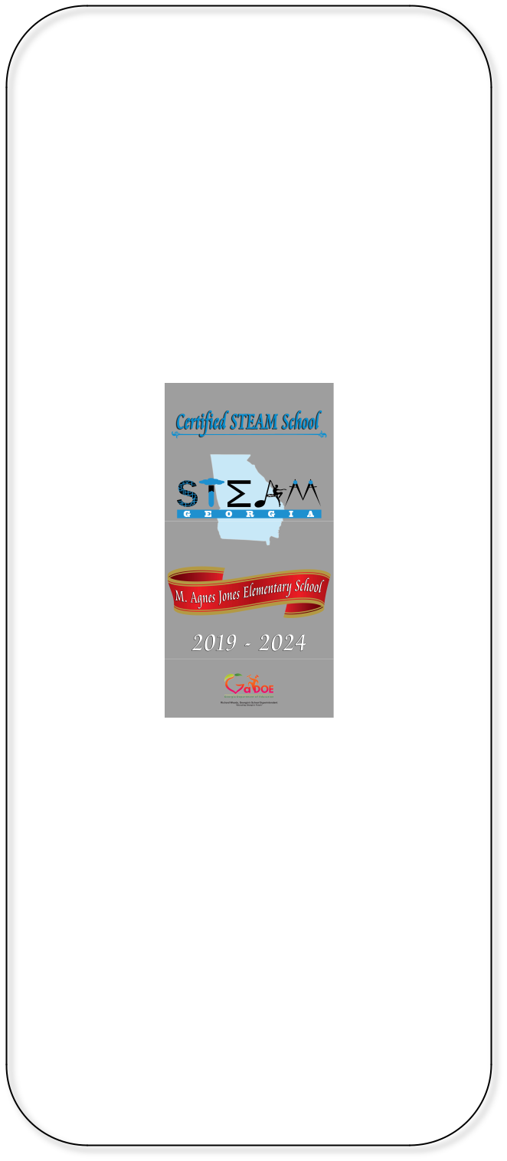

**M. Agnes Jones**

**Elementary**

**Dr. Teruko Dobashi, Principal**

http://www.atlantapublicschools.us/Domain/ 651

**404-802-3900**

**Revised: May 13, 2025**